## ****Capstone Project Synopsis****

**EVision – Smart Charging Forecasting & Location Planner**

### **1. Introduction**

The exponential growth of **Electric Vehicles (EVs)** is transforming urban mobility and accelerating the push toward sustainable transportation. However, this rapid adoption is creating new challenges for cities, energy providers, and EV operators — primarily in **predicting future charging demand** and **optimally locating charging stations**.

Current infrastructure often suffers from **poor placement**, **grid overload** in high-demand zones, and **underutilization** in low-demand areas. The lack of integrated, predictive intelligence in infrastructure planning leads to inefficient investments, congestion at charging points, and customer dissatisfaction.

**EVision** proposes an **AI-powered geo-intelligent system** that combines **time-series forecasting** (SARIMA + XGBoost) with **geospatial clustering** (K-Means on GIS data). This hybrid approach not only forecasts where and when EV charging demand will increase but also **identifies and ranks** the most suitable locations for new charging stations. An **interactive web dashboard** will display demand trends, hotspot maps, and site recommendations, empowering urban planners, EV operators, and policymakers to make **data-driven infrastructure decisions**.

### **2. Problem Statement**

With EV ownership rapidly increasing, existing charging station deployment strategies are struggling to keep up. Current planning approaches rely heavily on:

* **Historical usage data** without predictive capabilities.
* **Manual surveys** that are time-consuming and often outdated.
* **Siloed datasets** that don’t integrate spatial and temporal analysis.

This leads to several operational and economic issues:

* Overloaded grids in certain regions, causing **voltage drops** and longer charging times.
* Idle or **underused charging stations** in low-demand areas.
* Poor return on investment for EV infrastructure projects.

Most existing research focuses **only** on demand forecasting or **only** on site selection. There is **no unified solution** that integrates both predictive modeling and geospatial intelligence to recommend **where and when** to deploy new stations.

EVision aims to fill this gap by developing an **integrated forecasting and location-planning platform** that provides actionable recommendations, ensuring **efficient infrastructure deployment**, **reduced grid stress**, and **better user experience**.

### **3. Motivation**

The motivation for EVision stems from three converging trends:

1. **EV Boom & Infrastructure Gap**
   * EV adoption rates are accelerating globally and in India, but charging infrastructure growth remains slow and uncoordinated. This mismatch is creating bottlenecks that hinder EV adoption.
2. **Inefficiencies in Current Planning**
   * Poorly placed charging stations result in **wasted investments**, **high operational costs**, and **inconsistent accessibility** for users.
   * City planners and EV operators lack advanced **predictive analytics tools** for future-proof infrastructure planning.
3. **Need for Data-Driven Solutions**
   * The integration of **AI forecasting models** with **geospatial intelligence** can provide a proactive, rather than reactive, planning approach.
   * Such a solution aligns with **smart city initiatives**, supports **green mobility goals**, and enables **efficient energy distribution** by forecasting demand surges before they happen.

EVision is designed to address these challenges by offering a **scalable, accurate, and interactive decision-support system** that can adapt to changing mobility patterns, technological advancements, and evolving urban landscapes.

## ****4. Our Proposed Solution****

The proposed solution is an **AI-powered Geo-Intelligent Forecasting and Location Planner** designed to address the dual challenge of **predicting future EV charging demand** and **optimally locating new charging stations**.

Our approach integrates **time-series forecasting models** with **geospatial clustering techniques** to create a unified decision-support platform:

* **Demand Forecasting:**
  + Use **SARIMA** to model seasonal and long-term demand patterns.
  + Apply **XGBoost** to capture non-linear residuals and improve accuracy.
* **Spatial Analysis:**
  + Employ **K-Means clustering** on GIS-based features (traffic density, EV ownership distribution, grid capacity) to identify future demand hotspots.
* **Recommendation Engine:**
  + Score and rank potential sites based on forecasted demand, accessibility, and infrastructure support.
* **Visualization & Interaction:**
  + Deliver insights via an **interactive web dashboard** that includes geospatial maps, forecast graphs, and ranked site recommendations.

**Key Outcomes:**

* Proactive planning of EV charging infrastructure.
* Reduction in grid overload incidents and idle stations.
* Improved ROI for infrastructure investments.
* Alignment with smart city and green mobility goals.

**5. Software Requirements**

| **Software / Tool** | **Purpose** |
| --- | --- |
| **Python** | Core programming language for backend and data processing |
| **Flask / JavaScript (React.js / Vanilla JS)** | Web backend and interactive dashboard interface |
| **Pandas, NumPy** | Data preprocessing, manipulation, and numerical computation |
| **Statsmodels** | SARIMA time-series modeling |
| **XGBoost** | Non-linear residual learning and improved forecasting |
| **Scikit-learn** | Machine learning pipeline and K-Means clustering |
| **GeoPandas / Folium** | Spatial data handling, mapping, and GIS analysis |
| **Matplotlib / Plotly** | Data visualization, forecast graphs, and trend plots |
| **SQLite** | Data storage and retrieval |
| **Power BI** | Enhanced geospatial visualization and dashboard analytics |

**9. Flowchart**

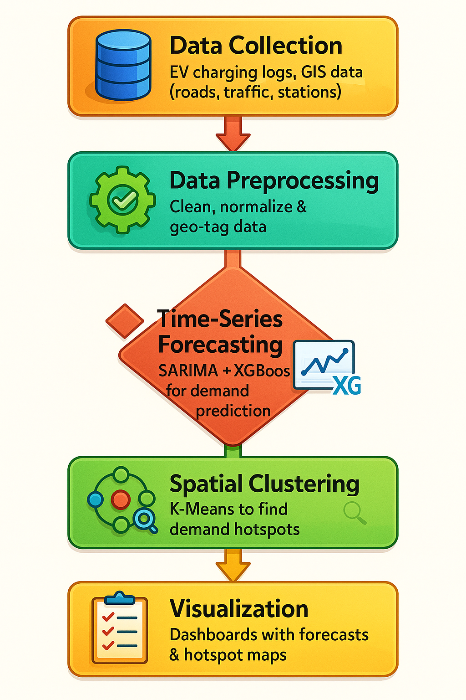

## ****7. Application Usage****

* **Urban Planning:**  
  Plan strategic EV charging infrastructure deployment in rapidly growing EV regions.
* **Smart Cities:**  
  Enable dynamic energy load balancing and integration with renewable energy grids.
* **EV Charging Operators:**  
  Improve ROI by targeting high-demand zones and avoiding underutilized stations.
* **Fleet & Logistics Management:**  
  Optimize charging schedules and routing for commercial EV fleets.
* **Government & Policy Making:**  
  Support green mobility initiatives, carbon reduction targets, and city-wide sustainability goals.

## ****8. Conclusion****

EVision presents a **comprehensive, AI-driven approach** to EV charging infrastructure planning by integrating **accurate demand forecasting** with **geospatial hotspot detection**.  
Through its hybrid **SARIMA + XGBoost** forecasting model, **K-Means clustering**, and **interactive dashboard**, the system bridges the gap between data analysis and actionable decision-making.

The outcome will be:

* **Optimized placement** of charging stations.
* **Reduced grid stress** during peak hours.
* **Improved user satisfaction** through shorter wait times and better accessibility.
* **Higher infrastructure ROI** for stakeholders.

By enabling **data-driven, predictive, and location-aware planning**, EVision aligns with smart city development and accelerates the adoption of sustainable transportation solutions.